21AIE112 Elements of computing systems - II

(INCLASS ASSIGNMENT)

Submitted By: Vikhyat Bansal [CB.EN.U4AIE21076]

Submitted To: Sreelakshmi Mam



Q1. Write a jack code for division of two numbers using division sign and inbuilt class.

CODE: Using Inbuilt Class

class Main {

*function* void main() {

*var* int a;

*var* int b;

*let* a = Keyboard.readInt("Enter the first number: ");

*let* b = Keyboard.readInt("Enter the second number: ");

*do* Output.printString("Divide: ");

*do* Output.printInt(Math.divide(a, b));

*return*;

}

}

Compiler Code:

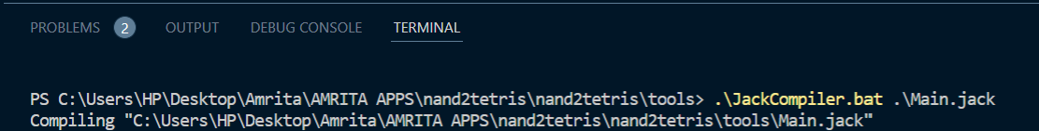

OUTPUT:  
With completely divisible number

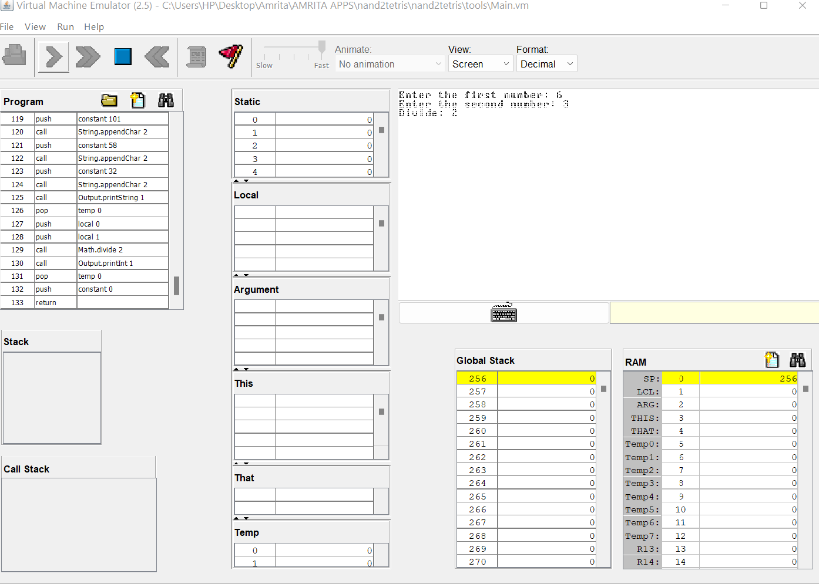

Without completely divisible number  
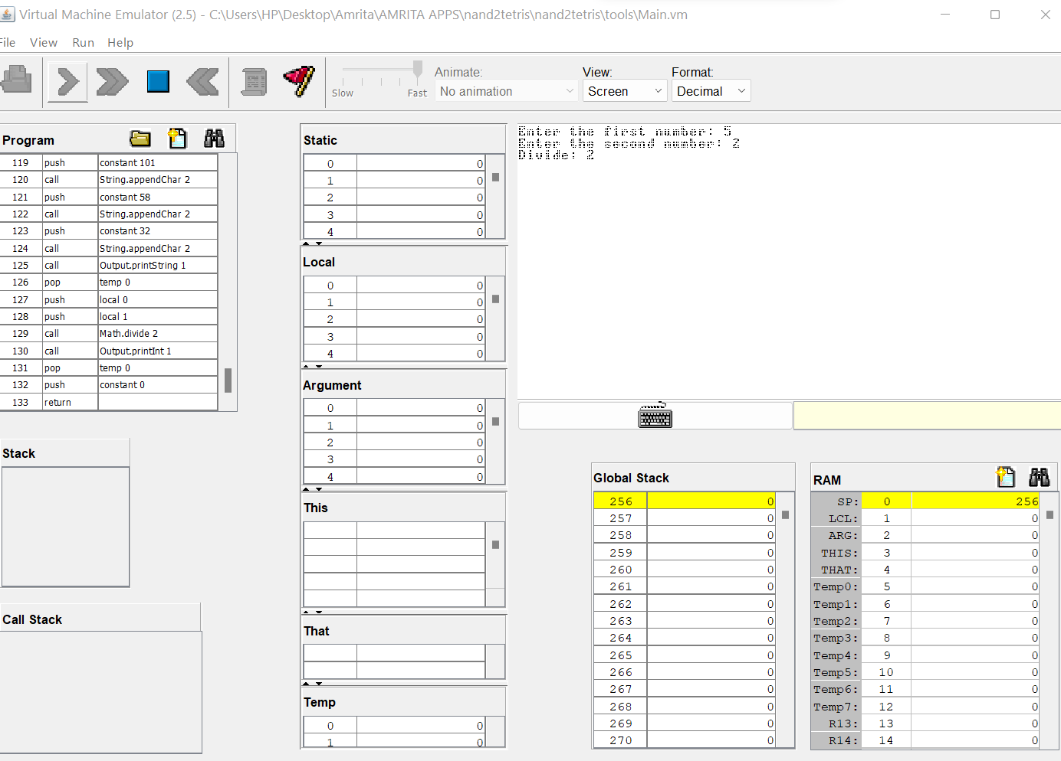

CODE: Using Divide Sign

class Main {

*function* void main() {

*var* int a;

*var* int b;

*let* a = Keyboard.readInt("Enter the first number: ");

*let* b = Keyboard.readInt("Enter the second number: ");

*do* Output.printString("Divide: ");

*do* Output.printInt(a/b);

*return*;

}

}

Compiler Code:



OUTPUT:  
With completely divisible number

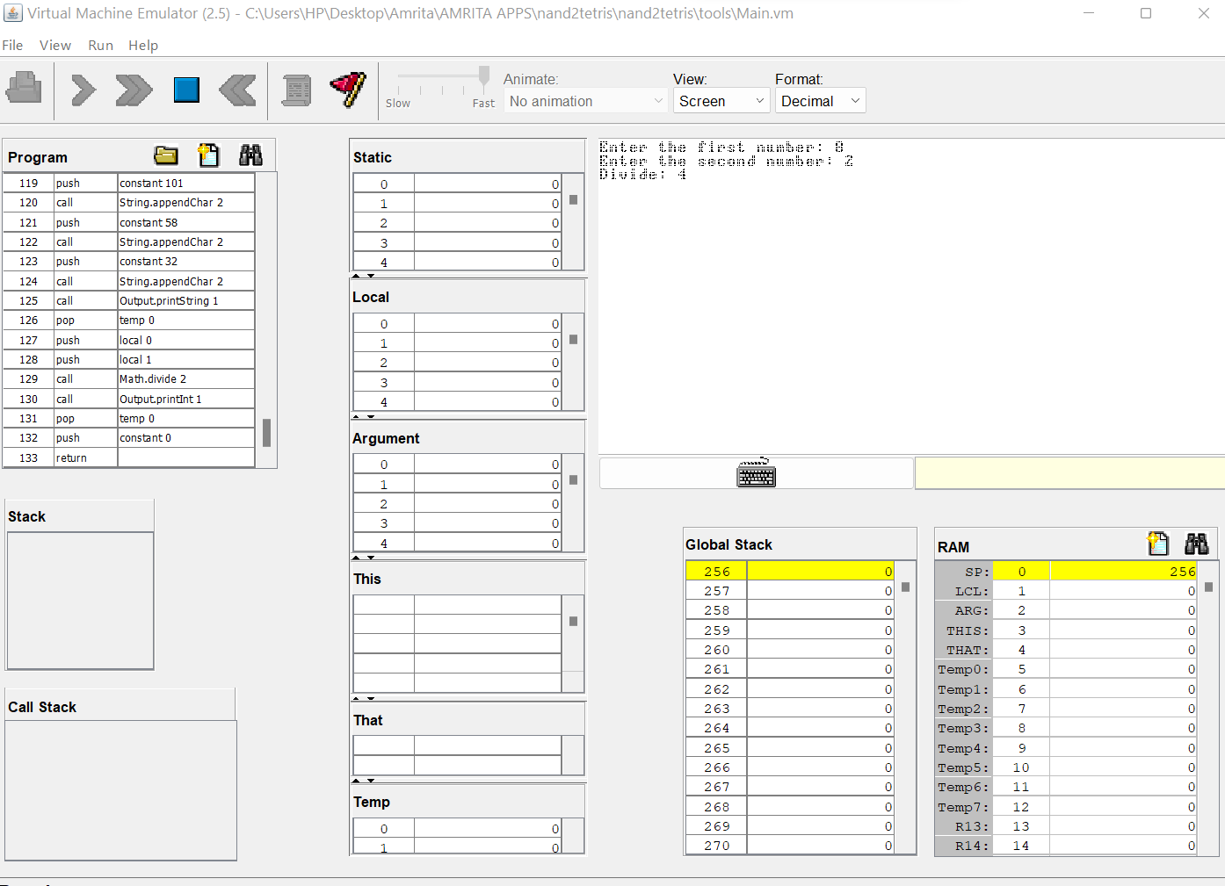

Without completely divisible number

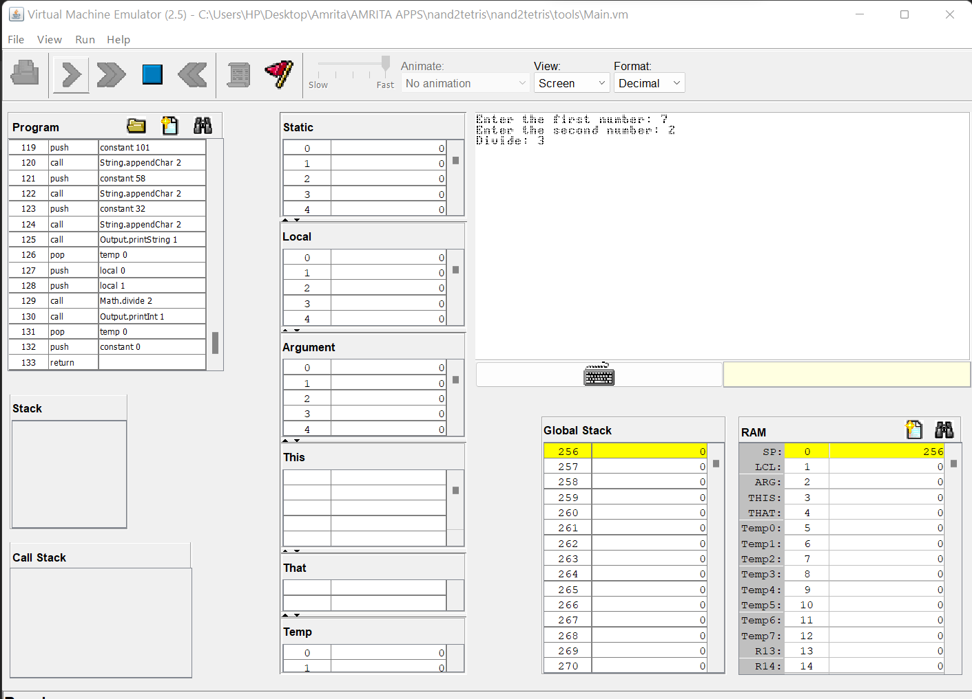

Q2. Write a jack code for division on your own without using division sign and inbuilt function.

CODE:

class Main {

*function* void main() {

*var* int a;  *//we created 4 integer variables namely a,b,c,neg*

*var* int b;

*var* int c;

*var* int neg;

*let* a = Keyboard.readInt("Enter first number: "); *//we read the first number*

*let* b = Keyboard.readInt("Enter second number: "); *//we read the second number*

*if* (b = 0) {

*do* Output.printString("Cannot divide by zero. Please enter a non-zero number. ");

*//if the second number is 0, we print this message*

*while*(b=0) {

*let* b = Keyboard.readInt("Enter second number: "); *//we read the second number again*

    }

    }

*let* neg = 0; *//we created a variable named neg*

*if* (a < 0) {

*let* neg = neg + 1; *//if the first number is negative, we add 1 to the variable neg*

*let* a = -a; *//we make the first number positive*

    }

*if* (b < 0) {

*let* neg = neg + 1; *//if the second number is negative, we add 1 to the variable neg*

*let* b = -b; *//we make the second number positive*

    }

*let* c = 0; *//we created a variable named c*

*while* ((a > b) | (a = b)) {

*let* a = a - b; *//we subtract the first number from the second number*

*let* c = c + 1; *//we add 1 to the variable c*

    }

*do* Output.printString("the Quotient is: ");

*if* (neg = 1) {

*do* Output.printInt(-c); *//if neg variable is 1 then only we print Quotient as negative*

    } *else* {

*do* Output.printInt(c);  *//if neg variable is 0 then only we print Quotient as positive*

    }

*return*;

  }

}

Compiler Code:



OUTPUT: With completely divisible dividend

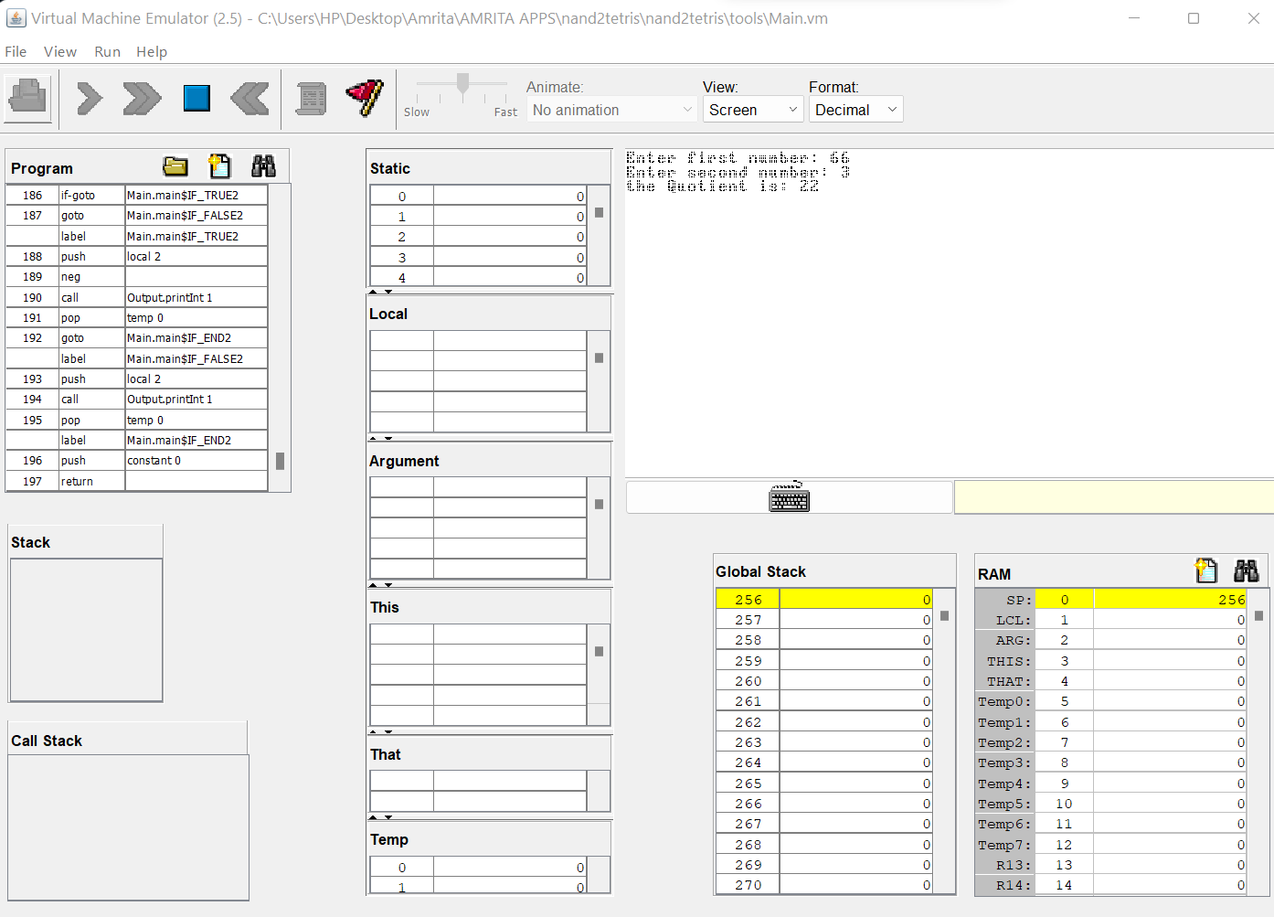

OUTPUT: Without completely divisible dividend

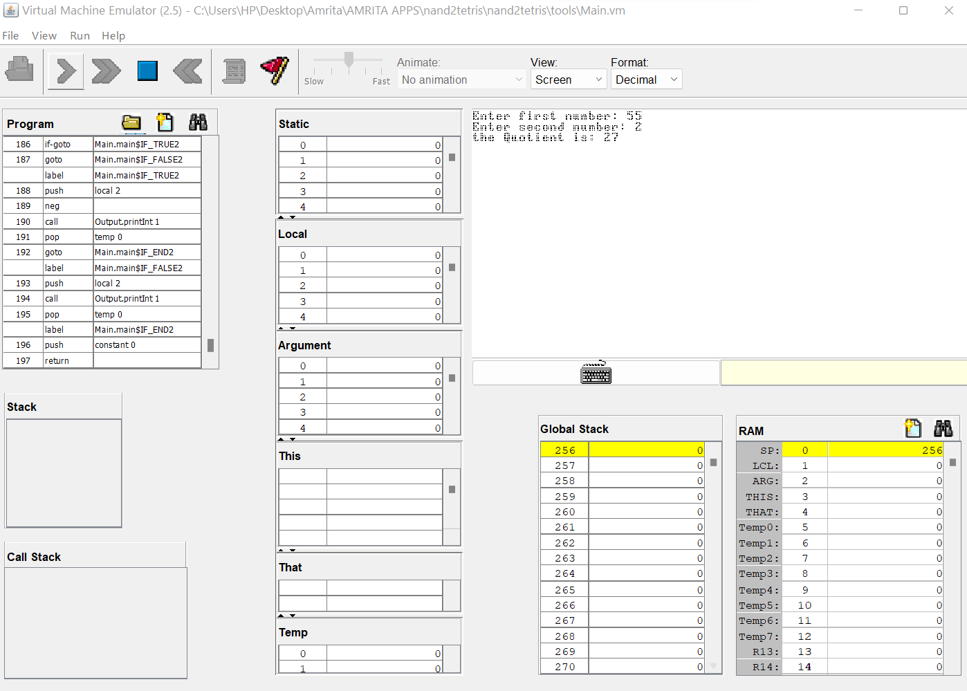

OUTPUT: With second number as ZERO

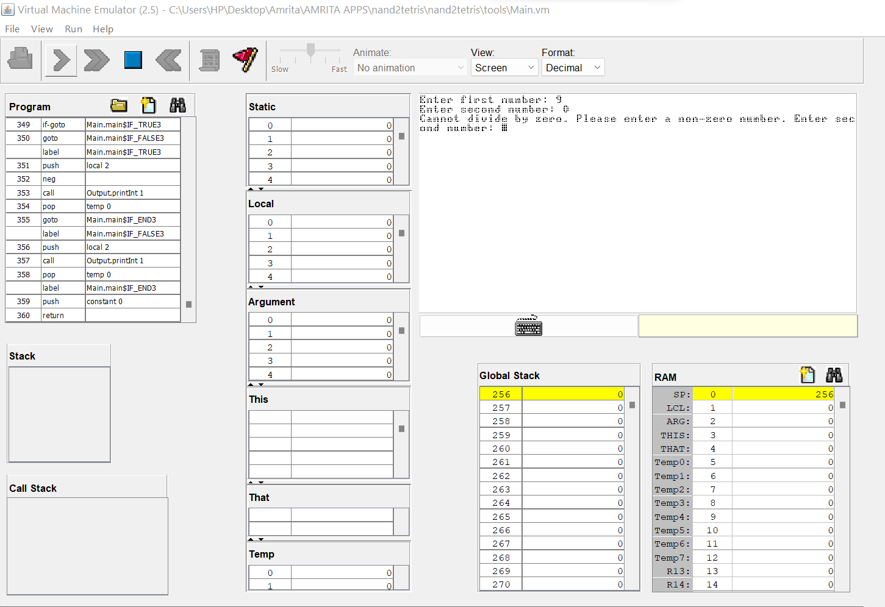

THANK YOU